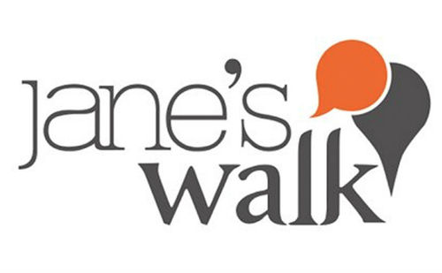
JANE’S WALK SASKATOON: Call for Walks
Jane’s Walk Saskatoon Festival Inc. is recruiting walk leaders for the coming Jane’s Walk Festival during the weekend of May, 5, 6, and 7, 2023. Walks can be either in person or virtual. Jane’s Walk Saskatoon Festival Inc. is committed to ensuring that in-person walks will be as safe as possible. In person walks will be cancelled if pandemic threat requires.*
Jane’s Walk is a movement of free, volunteer lead walking conversations inspired by Jane Jacobs. It encourages people to share stories about their neighbourhoods, discover unseen aspects of their communities, and use walking as a way to connect with their neighbours.
Anyone can lead a Jane’s Walk because everyone is an expert on the places they live, work, and play. Jane Jacobs believed that the people best equipped to understand cities and make decisions about them are “ordinary, interested citizens”. She intuited that getting to know our neighbourhoods and each other is the foundation of city-building. Jane’s Walk Leaders help people get to know their communities by gathering people outside of their homes, offices, and cars to exchange knowledge, tell stories, and share experiences.
Jane’s Walks are often walking tours, but they can also be bike rides, poetry readings, performance art, games, and more! There are three things that make a walk a Jane’s Walk:
Free, volunteer-led, and open to everyone: there can be no registration, fee, or donation associated with leading or participating in a Jane’s Walk.
Non-commercial and non-partisan: they cannot be used to promote a business or a candidate running for office.
Seek to promote dialogue: Jane’s Walks are dialogues that seek to engage participants in conversation and are usually 40 – 60 minutes long.
Decide on a topic, theme, or neighbourhood to explore. Think of a place or idea you’d like to explore in Saskatoon. What do you know that you want to share with your community? What do you not know that you want to learn about? What do you care about and wish others cared about, too? What do you love about Saskatoon? What would make Saskatoon better?
Additional information about the 2023 Jane’s Walk Festival Weekend can be found at: https://janeswalksaskatoon.ca/ or https://www.facebook.com/JanesWalkSaskatoon/ or call: Murray Gross at (306) 244-0767.
*NOTE: the Jane’s Walk Steering Committee encourages City Organizers to make decisions about their local festivals that prioritize the health, safety, and wellbeing of their communities. Given the wide range of current pandemic threat levels in different regions of the world, this year we believe it is most important that you seek and follow the guidance of the local public health authorities where you live. https://janeswalk.org/

How to lead a Jane’s Walk

